**CT USIP – 1 Prelaunch Notice 11/02/2019**

**NOTAM (Notice to Airmen) Number DXR 11002**

1. The balloon identification: CT USIP – 1
2. The estimated date and time of launching, amended as necessary to remain within plus or minus 30 minutes: 3rd November 2019 (Sunday) @ 16:00 UTC
3. The location of the launching site:

Address: 4510 Park Avenue, Bridgeport, CT 06604

Coordinates: 41.218601, -73.234958

1. The cruising altitude: 11,000 meters
2. The forecast trajectory and estimated time to cruising altitude or 60,000 feet standard pressure altitude, whichever is lower:

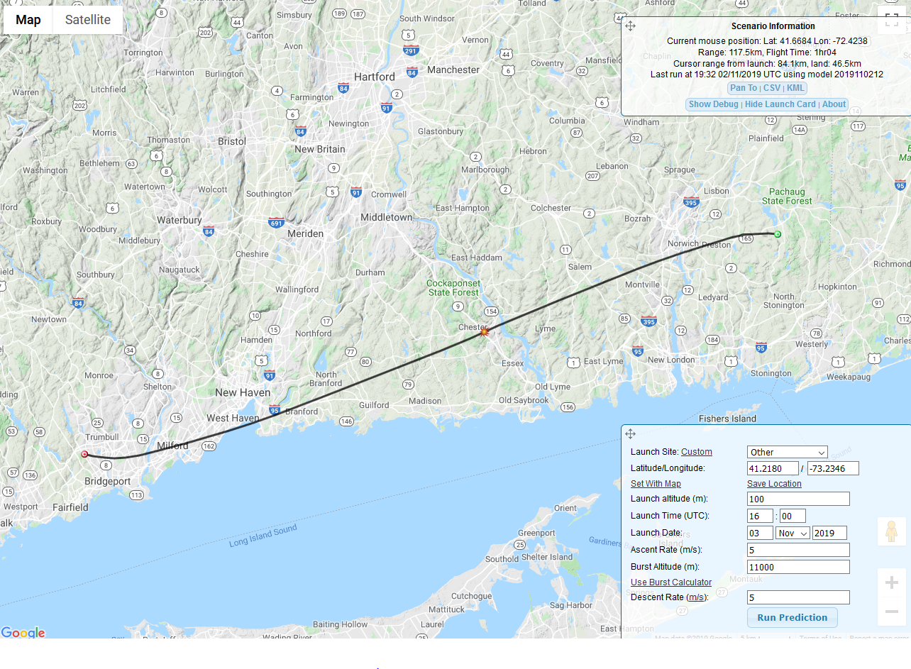

Estimated time to cruising altitude – 40 minutes

1. The length and diameter of the balloon, length of the suspension device, weight of the payload, and length of the trailing antenna:

Balloon: 1500-gram white latex weather balloon filled with Helium

Payload 1 Dimensions: 9 ¾” X 10.5” X 12”

Payload 2 Dimensions: 15 3/8” X 14 1/8” X 19 3/8”

Payload 1 Weight: 4 pounds 6.7 ounces

Payload 2 Weight: 6 pounds

Radar Reflector: 11” diameter 7.5 ounces

Payload train length: 32 feet

1. The duration of flight – 1 hour
2. The forecast time and location of impact with the surface of the earth: 41.3413N

-71.9491W @ 16:59 UTC

Notes:

1. Launch site cell phone number: (203) 300-9095
2. In-flight GPS/APRS tracking available at <http://www.aprs.fi> Call Sign: AB1JC-11
3. Launch and landing notifications will be called in at (516) 683-2984 (Approach Control NY) and (203) 378-4106 (Sikorsky)
4. Phone number to file a NOTAM: (877) 487-6867